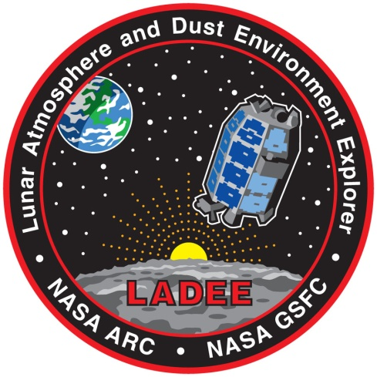

Lunar Atmosphere
and Dust Environment Explorer
(LADEE)
Project

Ultraviolet-Visible Spectrometer Planetary Data System Software Interface Specification

DRAFT
January 18, 2013

Signatures
(Signatures on this page are electronic via the GSFC MIS system for LADEE)

Prepared By:
TBD DATE
LADEE UVS TBD

Concurred By:
TBD DATE
LADEE UVS TBD

TBD DATE
PDS TBD

TBD DATE
LADEE TBD

TBD DATE
LADEE TBD

Approved By:
Dr. Anthony Colaprete DATE
LADEE UVS Principal Investigator

TBD DATE
LADEE Payload Manager

CONFIGURATION MANANAGEMENT FOREWORD
This document is a LADEE Payload controlled document. Changes to this document require prior approval of the LADEE Payload CCB Chairperson. Proposed changes shall be submitted to the LADEE Payload Configuration Management Office (CMO), along with supportive material justifying the proposed change.
Questions or comments concerning this document should be addressed to:
LADEE Payload Configuration Management Office
LADEE Payload Configuration Manager
Mail Stop 460
Goddard Space Flight Center
Greenbelt, Maryland 20771

REVISION HISTORY
Rev. | Description of Change |  | Author(s)

Contents

1 Purpose and scope of document 5
1.1 Applicable documents and constraints 6
1.2 Relationship with other interfaces 6
2 Data product characteristics and environment 6
2.1 Instrument overview 6
2.2 Data product overview 8
2.3 Data processing 8
2.3.1 Data processing level 8
2.3.2 Data product generation 9
2.3.3 Data flow 9
2.3.4 Labeling and identification 9
2.4 Standards used in generating data products 9
2.4.1 PDS standards 9
2.4.2 Time standards 10
2.4.3 Coordinate systems 10
2.4.4 Data storage conventions 10
2.5 Data validation 10
3 Detailed data product specifications 10
3.1 Data Product structure and organization 10
3.2 Data format description 10
3.3 Label and header descriptions 10
3.3.1 Raw-level data products 11
3.3.2 Calibrated-level data products 11
4 Applicable software 12
4.1 Utility programs 12
4.2 Applicable PDS software tools 12
4.3 Software distribution and update procedures 12
5 Archive volume contents 12
5.1 Root directory contents 12
5.2 Data directory contents and naming 12
5.3 Index directory contents 13
5.4 Document directory contents 13
5.5 Catalog directory contents 14
5.6 Label directory contents 14
5.7 Software directory contents (if necessary) 14
5.8 Calib directory contents 14
5.9 Geometry directory contents (if necessary) 14
5.10 Browse directory contents (if necessary) 14
5.11 Extras directory contents (if necessary) 14
6 Archive volume format 14
6.1 Disk format 14
6.2 File formats 14
6.2.1 Document file format 14
6.2.2 Tabular file format 14
6.2.3 PDS label format 14
6.2.4 Software file format (if necessary) 14
6.2.5 Catalog file format 14
6.2.6 Science data file formats 14
7 Archive volume generation 14
7.1 Data transfer and validation methods 14
7.2 Data product sizes and delivery rates 14
7.3 Interface media characteristics 14
7.4 Backups and duplicates 14
7.5 Labeling and identification 14
8 Roles and responsibilities 14
9 Appendices 15
9.1 Glossary 15
9.2 Acronyms 15
9.3 Definitions of Data Processing Levels 15
9.4 Data-product label fields 15
9.5 Example PDS label 17

Purpose and scope of document
This document describes the data archived in the Planetary Data System (PDS) by the Lunar Atmosphere and Dust Environment (LADEE) Ultraviolet and Visible Spectrometer (UVS). It is both the Data Product SIS and the Archive Volume SIS for UVS. It is written for scientists, software engineers, and others who wish to understand the contents of the UVS Archive, including users associated with the project and those in the general planetary science community. It explains the structure and contents of the archive, including a detailed description of the spectral data products and how they were generated. It describes the UVS instrument, its observational activities, and the data products produced by the UVS team and the steps used to derive them. It is intended to provide the information necessary to use and reproduce the data products.

Applicable documents and constraints
The LADEE UVS SIS complies with the following documents:
- LADEE Data Management and Analysis Plan (C10.LADEE.SDMAP )
- UVS-PDS Interface Control Document
- Should also include PDS4 documents such as Standards Reference
The descriptions of the instrument, settings, observational activities, raw data products, calibration, and relationship with the LADEE spacecraft are derived from the:
- LADEE mission description
- LADEE spacecraft description
- UVS Operations Plan (PLA-LADEE-UVS-PLAN-0050)
- UVS Calibration Plan
- UVS to LADEE Interface Control Document (ICD-011.LADEE.UVS)

Relationship with other interfaces
The UVS data products are stored in multiple locations according to the LADEE Project Data Management and Archive Plan (DMAP). Copies will be stored at ARC for use by the UVS Science Team. These copies will be derived from the products generated by UVS for delivery to the PDS as described by the LADEE UVS PDS Interface Control Document. The LADEE project will also deliver a SPICE Archive to the NAIF (the Navigation and Ancillary Information Facility at JPL) containing spacecraft trajectory, attitude and clock information. The products in the UVS delivery to the PDS will contain information derived from this SPICE Archive, specifically spacecraft position and attitude at the time of every UVS observation, and this information will be the best available at the time the UVS Archive is delivered to the PDS. Users wanting the best possible information, however, are encouraged to check with the NAIF for updates.

Data product characteristics and environment

Instrument overview
The UVS instrument will be carried aboard the LADEE mission to perform spectral characterization of the lunar atmospheric dust. This characterization will entail measuring the relative concentrations of certain species, and noting the spatial and temporal distributions of those species. The main components of the UVS system are an ultraviolet/visible spectrometer, a limb viewing telescope and a solar viewing optic. The instrument is shown in Figure 1.
The UVS telescope and the solar viewer are connected with fiber optic cable to the spectrometer. They share a common detector, and hence their fiber connectors merge. There is no switch or gate. This has some operational impact: in general, when gathering data with one, the other cannot be pointed at a significant source of light. (This paragraph needs quite a bit more description.)
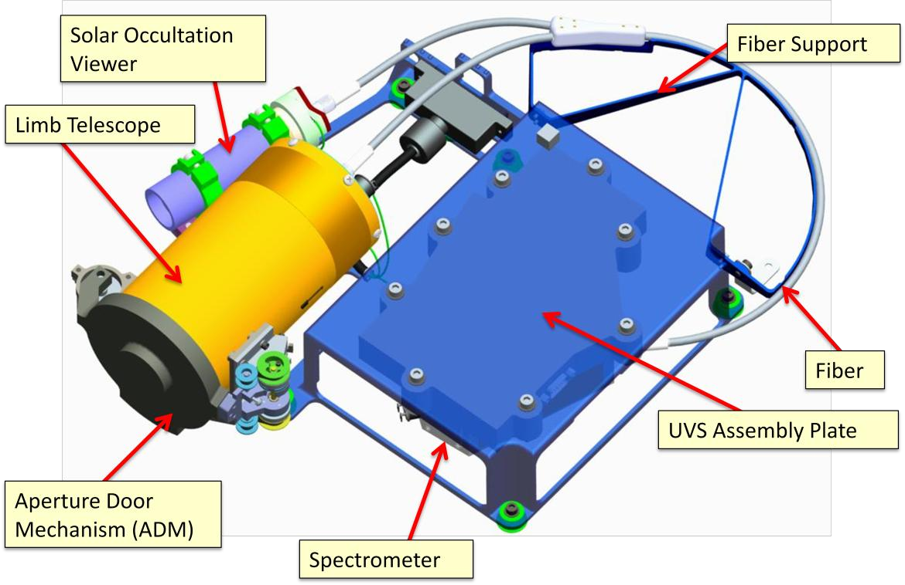Figure 1: Components of the UVS instrument
Observations by UVS are organized into several types of “activities,” including telescope observations just above the lunar limb and in a direction opposite LADEE’s orbital motion (i.e., looking roughly east), similar but less frequent observations looking north, west and south, all made at various lighting angles. Also included are telescope observations made on the night side of the orbit looking anti-sunward of sodium atoms pushed by the solar wind, solar viewer observations of forward scattering from dust and gasses lit from behind as the sun sets due to LADEE’s orbital motion, and calibration activities. Definitions of these activities are provided in the UVS Operations Plan. (Will this document be available not just for the archive but for the SIS review? Will it be in public domain at all?)
The UVS instrument does not have high-level operational modes beyond ON and OFF; the operational parameters that will vary are the sample rate, integration time and detector temperature. There is no safe mode, besides being OFF. There are two modes for gathering data, polled and streaming. The UVS team plans to use streaming mode exclusively. (Which begs the question: why have polled at all?)
The data coming down from the UVS is in the format of binary spectra and metadata, such as the current detector temperature and imaging parameters. The UVS does not have separate housekeeping telemetry. The UVS to LADEE Interface Control Document contains detailed descriptions of the instrument and its interface to the spacecraft, including instrument parameters and returned data.

Data product overview
UVS provides a single type of data product, consisting of a spectrum for each instrument observation containing data from 250 to 800 nm. The same product type is used for both occultation and limb-viewing observations. Each product is provided at two data processing levels: the unmodified raw count data returned from the instrument and the calibrated radiance derived from the raw counts.
Data are received from the LADEE spacecraft in Consultative Committee for Space Data Systems (CCSDS) packets, one packet per spectrum. Each packet contains a raw spectrum consisting of a sequence of 4 blank pixels, 6 bevel pixels, 1024 active pixels, and 6 bevel pixels and 4 blank pixels, each one a 16-bit binary integer. The bevel pixels are a result of the back thinning of the CCD detector, and the blank pixels can be monitored to assess the level of the inherent dark signal in the detector. The blank pixels are extra shift-registers embedded within detector substrate and do not correspond to active light-sensing detector elements.
Perhaps a paragraph describing the conversion from binary packets to raw DNs?
Each UVS spectrum submitted to the PDS is provided in the form of two ASCII tables converted from the binary packet data. One contains raw data numbers as a function of spectrometer bin number and the other contains calibrated radiances and wavelengths for each bin. Both are accompanied by a PDS4-format Extensible Markup Language (XML) label.
The UVS team will also provide a set of ancillary data products, including a calibration report containing wavelength and radiance calibration functions.

Data processing

Data processing level
The data-processing levels employed by the LADEE mission are established in the LADEE Data Management and Analysis Plan (DMAP). The mission will use the levels defined in the PDS4 standard. The levels are shown in DMAP Table 4-1 and are reproduced here in Table 1.
The UVS team will produce data products at two of the DMAP levels: Raw and Calibrated. The Raw-level products will provide the unmodified digital-number counts from the detector for each observation. The Calibrated-level data will consist of spectra reduced to radiance per pixel with cosmic-ray artifacts removed. All products will be labeled with time-stamps and instrument targeting information.
Table 1: Data processing levels.
Product | Description
Packet Data | Telemetry data stream as received at the ground station, with science and engineering data embedded.
Raw | Original data from an instrument. If compression, reformatting, packetization or other translation has been applied to facilitate data transmission or storage, those processes will be reversed so that the archived data are in a PDS approved archive format.
Reduced | Data that have been processed beyond the raw stage but which are not yet entirely independent of the instrument.
Calibrated | Data converted to physical units entirely independent of the instrument.
Derived | Results that have been distilled from one or more calibrated data products (for example, maps, gravity or magnetic fields, or ring particle size distributions). Supplementary data, such as calibration tables or tables of viewing geometry, used to interpret observational data should also be classified as derived data if not easily matched to one of the other three categories.

Data product generation
All UVS PDS data products are produced by the UVS instrument team. The products are the same ones used by the LADEE science team and are generated and used as delivered to PDS by the UVS data-processing pipeline

Data flow

Labeling and identification
Each UVS data product is uniquely identified by a PDS4 logical identifier constructed from its timestamp and an indication of its data-processing level. The identifiers have the form “urn:nasa:pds:ladee:uvs:[level]:[timestamp],” where “[level]” can either be “raw” or “calibrated” and “[timestamp]” is the uncorrected timestamp of the observation in human-readable form, e.g. “2013278143023816.” These digits represent year, day-of-year, hour, minute, second, and millisecond. (May also want to include file naming convention here.)

Standards used in generating data products

PDS standards
UVS data products comply with Planetary Data System standards for file formats and labels. The current revision of the products complies with the latest PDS4 draft standards, including the second draft of the PDS4 Concepts document and Version 0.3.8 of the PDS4 Data Providers Handbook. The UVS data products will be updated as necessary as final revisions of the standards are adopted.

Time standards
All absolute times contained in UVS products are expressed in Coordinated Universal Time (UTC). The primary timestamp for each spectrum is an absolute time generated by the spacecraft clock, which will be calibrated to stay close to UTC. Each spectrum will contain this timestamp as well as a corrected timestamp that reflects the mission’s best estimate of the correct UTC time. A third timestamp is provided for each spectrum that is generated by the instrument. These instrument timestamps are relative to when UVS was last powered on. They give useful information about the times between spectra collected during a single activity and for validating the correctness of the absolute timestamps.

Coordinate systems
Spatial coordinates indicating information related to spacecraft position, instrument pointing, etc. occur in the UVS data product PDS4 label files. All such coordinates are expressed in the Lunar Reconnaissance Orbiter (LRO) Mean Earth/Polar Axis (ME) frame, as described in “A Standardized Lunar Coordinate System for the Lunar Reconnaissance Orbiter, LRO Project White Paper, 451-SCI-000958, Version 4, May 14, 2008.”

Data storage conventions

Data validation (Section needs work)
Data content validation will be performed by the UVS science team prior to delivery to PDS. Data structure and format will be performed by the UVS science team and the PDS data review team as described in Section 4.3.

Detailed data product specifications
Each observational integration has two associated data products–one product each for the Raw and Calibrated data-processing levels.

Data Product structure and organization
Each product consists of two files, one containing the XML PDS4 label describing the product and one containing the data object. The label contains information identifying and describing the observation. It includes metadata essential for interpreting the spectrum, such as instrument settings during the observation, solar angles, instrument state, etc. The data object file contains the spectrum in a human-readable tabular form.

Data format description
UVS data products are stored in PDS4 formats. Each data object file consists of a PDS4 Product_Table_Character listing the spectral data in PDS4 repeating_record_structure format. A detailed definition of the table format may be found in the PDS4 Concept documents, and the layout of a particular table is defined in its corresponding label.

Label and header descriptions
The PDS4 label associated with each data product identifies the observation, describes the observational field and state of the instrument, and describes the contents of the data objects. It includes the time of the observation, pointing information, instrument settings, and defines the record types of the columns of the measurement data. The labels will be instances of the PDS4 Product_Observational class. The contents of the label fields are described in detail in an appendix, Section .

Raw-level data products
A Raw-level table has only two columns: one containing detector bin numbers and another containing the raw measurement from each bin. A table contains 1044 records—one for each detector bin, including the masked calibration pixels. (It will probably be useful here to identify exactly which bins are calibration and otherwise non-observational.)
Table 2: Raw-level data table columns.
Name | Field number | Field location | Data type | Field length | Unit | Description
Bin | 1 | 1 | ASCII_Non_Negative_Integer (Maximum: 65535) | 5 |  | Detector pixel number.
Value | 2 | 12 | ASCII_NonNegative_Integer (Maximum: 65535 if the number of scans to accumulate is set to 1; 4,294,967,295 if the accumulation count is set to > 1.) | 10 | Digital number (DN) | Unmodified measurement.

Calibrated-level data products
A Calibrated-level table consists of three columns: one giving the bin number, one stating the calibrated wavelength of the bin, one for the radiance of that bin. (Cosmic ray hits are handled as described in Section ???) Each table has 1024 records—one for each spectral bin.
Table 3: Calibrated-level data table columns.
Name | Field number | Field location | Data type | Field length | Unit | Description
Bin | 1 | 1 | ASCII_Non_Negative_Integer (Maximum: 65535) | 5 |  | Detector pixel number.
Wavelength | 2 | 17 | ASCII_Real | 15 (?) | Nanometer | Calibrated wavelength corresponding to each pixel, derived as described in XXX. (I can't imagine we need to include this for every measurement. Do we expect it to ever change? I guess it could after calibration events. Perhaps we should just have a table of wavelengths as measured during each calibration.)
Radiance | 3 | 35 | ASCII_Real | 15 (?) | Watt nanometer⁻¹ meter⁻² steradian⁻¹? | The radiance of the observed spectrum, derived as described in XXX.

As noted, the field length and field location entries are probably incorrect.

Applicable software

Utility programs

Applicable PDS software tools

Software distribution and update procedures

Archive volume contents
This section contains the contents of the UVS Archive volumes, including the file names, file contents, file types, and organization responsible for providing the files.

Root directory contents
The root directory contains files describing the bundle and sub-directories containing three collections: the Raw-level product collection, the Calibrated-level product collection, and the Document collection. The contents are listed in Table 4.
Table 4: Contents of the root directory
File or directory | Contents
bundle.xml | PDS label for the UVS bundle.
README | Text description of the contents of the bundle.
data_raw/ | Raw spectra collection.
data_calibrated/ | Calibrated spectra collection.
document/ | Document collection.
Context/
Xml_schema/

Data directory contents and naming
The structure of the Raw- and Calibrated-level collections are identical. Their contents are shown in Table 5. Both contain data products for every UVS observation during the mission, organized by timestamp. Because of the large number of observations during the mission, the products are stored in subdirectories grouped by the year, month, and day of the observations.
Table 5: Contents of data_raw/ and data_calibrated/, the Raw- and Calibrated-level data product collections. The structure of the contents of both are identical.
File or directory | Contents
collection.xml | Label for the collection; describes collection.tab.
collection.tab | List of spectral products in the collection.
products/(Probably don’t need this layer.) | The data products.
products/[year]/[month]/[day]/ | All products for a given day.
products/[year]/[month]/[day]/[timestamp].xml | Label for a product with a given timestamp.
products/[year]/[month]/[day]/[timestamp].tab | Spectral data table for a product with a given timestamp.

Index directory contents (delete)

Document directory contents
The document collection contains files describing the mission, instrument, and observational data. The contents are listed in Table 6.
Table 6: Contents of document/, the document collection. Each file also has an associated PDS4 XML label file.
File or directory | Contents
collection.tab | List of products in the documentation collection.
LADEE_UVS_SIS.pdf | This document—the UVS Software Interface Specification.
investigation_ladee.pdf | LADEE mission description.
instrument_host_ladee.pdf | LADEE spacecraft description.
instrument_uvs.pdf | UVS instrument description,
LADEE_UVS_calibration.pdf | Detailed description of the UVS calibtration process.
 | UVS Operations Plan (PLA-LADEE-UVS-PLAN-0050)

Catalog directory contents (delete)

Label directory contents (delete)

Software directory contents (if necessary) (delete)

Calib directory contents (delete presumably)

Geometry directory contents (if necessary) (delete)

Browse directory contents (if necessary) (delete)

Extras directory contents (if necessary) (delete)

Archive volume format (deletE)

Disk format

File formats

Document file format

Tabular file format

PDS label format

Software file format (if necessary)

Catalog file format

Science data file formats
Necessary because we've combined the Data Product & Archive Volume SISs?

Archive volume generation

Data transfer and validation methods
Need to discuss validation here, since it's in the data-product sections?

Data product sizes and delivery rates
Include schedule for archive release to PDS here?

Interface media characteristics

Backups and duplicates

Labeling and identification

Roles and responsibilities
Support staff and cognizant persons
Refer to DMAP.

Appendices

Glossary

Acronyms

Definitions of Data Processing Levels

Data-product label fields
The UVS data product labels contain fields providing metadata about each observation. Some are standard PDS4 fields and others are UVS-specific. The attributes contained in the Raw- and Calibrated-level labels are identical. They are listed in Tables 7–12, broken down by the major sections in a PDS4 label. The fields in Tables 7–11 are standard attributes included in all PDS 4 product labels. The fields in Table 12 are UVS-specific. They indicate the purpose of the observation and provide relevant instrument and spacecraft state and settings.
Table 7: Data product label Identification_Area fields.
Field | Description
logical_identifier | Unique identifier for the product. The product-specific section consists of the spectrum’s uncorrected timestamp in human-readable form, e.g.,  urn:nasa:pds:ladee:uvs:raw:2013278143023816.
Table 8: Data product label Observation_Area/Time_Coordinates fields.
Field | Description
start_date_time | Corrected UTC time of the start of integration.
stop_date_time | Corrected UTC time of the end of integration.
Table 9: Data product label Observation_Area/Investigation_Area fields.
Field | Description
name | LADEE
type | Mission
internal_reference | ??
Table 10: Data product label Observation_Area/Observing_System fields.
Field | Description
name | UVS
observing_system_component_type | Instrument
Table 11: Data product label Observation_Area/Target_Identification fields.
Field | Description
name | Name of the observation’s primary target. UVS has two active apertures at all times, and this value doesn’t distinguish which aperture can view this target. Elements within Mission_Area disambiguate this.
type | The type of the primary target

Table 12: Data product label Observation_Area/Mission_Area fields.
Field | Type | Description
uvs:sequence_number | Integer; [0,65535] inclusive; counts to 65535 then wraps back to 0 | Spectrum number in Streaming Mode sequence. Zero in Polling Mode.
uvs:start_time(let’s change this to something more specific) |  | On-board clock mission-elapsed time at which the integration started, in integer (milli/micro?) seconds.
uvs:activity_type |  | Name of the type of activity for which the observation was made. Permissible values include “Limb,” “Occultation,” “Sodium-Tail,” “North-South,” and “Calibration.”
uvs:aperture |  | Indicates whether the intent was to view the target with the limb telescope or the solar viewer. Permissible values are “telescope” and “solar_viewer.”
uvs:telescope_target |  | Symbolic description of field-of-view. One of ‘lit-moon’, ‘unlit-moon’, ‘sky’, ‘sun’, ‘door’
uvs:solar_viewer_target |  | Symbolic description of field-of-view. One of ‘lit-moon’, ‘unlit-moon’, ‘sky’, ‘sun’, ‘door’
uvs:integration_time | Integer; [0, 65535] | The detector integration time for the observation, in milliseconds.
uvs:accumulation_count | Integer; [1, 10000] | Number of scans for instrument to accumulate for each acquisition.
uvs:tec_enabled | Boolean | “True” indicates that the thermo-electric cooler (TEC) is enabled; “False” indicates that it is not.
uvs:tec_setpoint | Integer; [-200, 70]. | Thermo-electric cooler temperature setpoint to which the cooler tries to drive the detector temperature. The setpoint temperature, T, is related to the returned value, s, through T = s * 0.1 °C. (Is this correct?)
uvs:detector_temp | Integer; [-700, 700]. | Thermo-electric cooler cold-side temperature, which is the best estimate of the temperature of the detector. The temperature, T, is related to the returned value, s, through T = s * 0.1 °C.
uvs:tec_hot_side_temp | Integer; [-700, 700]. | Thermo-electric cooler hot-side temperature. The temperature, T, is related to the returned value, s, through T = s * 0.1 °C.
uvs:spectrometer_timestamp | Integer between 0 and 4,294,967,295. | Time, in milliseconds, since the instrument’s processor booted.
uvs:checksum_valid | Boolean | “True” indicates that the checksum sent by the instrument was correct; “False” indicates otherwise. (Include the actual checksum value under the raw data? - no)
uvs:spacecraft_timestamp (?) | Non-negative integer. | Spacecraft clock time in subseconds (2^-16 sec) since the mission epoch (200-001-11:58:56.818) at which the observation was received from the instrument by the spacecraft. This clock will be maintained to within 4 seconds of UTC during UVS observations.
time (Needs better keyword) | Non-negative integer | Uvs:spacecraft_timestamp corrected to UTC. This timestamp is used to derive start_date_time and stop_date_time as described in section xxx.
uvs:spacecraft_position_vector | Float3Vector | Position of the spacecraft in the Lunar Reconnaissance Orbiter Mean Earth / Polar Axis (ME) lunar reference frame (Include canonical reference!), in meters.
uvs:limb_telescope_view_vector | Float3Vector | Vector from the spacecraft to the intersection of the telescope boresight vector and the lunar reference sphere (ref) or, if there is no intersection, the point along the boresight vector closest to the reference sphere.
uvs:occulation_view_vector | Float3Vector | Vector from the spacecraft to the intersection of the solar occultation viewer boresight vector and the lunar reference sphere (ref) or, if there is no intersection, the point along the boresight vector closest to the reference sphere.
uvs:telescope_grazing_point_latlon (latlon keywords should be separated into pairs of keywords) | 2 x ASCII_Real? Float3Vector? | Latitude and longitude in ME frame of the intersection of the telescope boresight vector and the LRO lunar reference sphere (?) or the closest point on the reference sphere to that vector.
uvs:telescope_grazing_point_solar_latlon | 2 x ASCII_Real? Float3Vector? | Solar latitude and longitude in ME frame of the intersection of the telescope boresight vector and the LRO lunar reference sphere (?) or the closest point on the reference sphere to that vector.
uvs:occultation_grazing_point_latlon | 2 x ASCII_Real? Float3Vector? | Latitude and longitude in ME frame of the intersection of the solar occultation viewer boresight vector and the LRO lunar reference sphere (?) or the closest point on the reference sphere to that vector.
uvs:occultation_grazing_point_solar_latlon | 2 x ASCII_Real? Float3Vector? | Solar latitude and longitude in ME frame of the intersection of the solar occultation viewer boresight vector and the LRO lunar reference sphere (?) or the closest point on the reference sphere to that vector.
uvs:telescope_grazing_altitude | ASCII_Real | Distance from the point specified by the uvs:telescope_grazing_point_latlon and the uvs:limb_telescope_view_vector.
uvs:occultation_grazing_altitude | ASCII_Real | Distance from the point specified by the uvs:telescope_grazing_point_latlon and the uvs:limb_telescope_view_vector.
uvs:lunar_sub-solar_point (latlon) | 2 x ASCII_Real? | Latitude and longitude of the sub-solar point in the LRO ME frame. (The location of the sub-solar point provides the location of terminator. Should we provide any other representations of the location of the terminator? E.g., a distance along the boresight vector?)
ladee:sub_satellite_latlon | Float3Vector | Latitude and longitude in ME frame of the sub-spacecraft point
ladee:sub_satellite_solar_latlon | Float3Vector | Solar latitude and longitude in ME frame of the sub-spacecraft point

Example PDS label

